Social Sport Ladder
User Guide
Player Page
This page displays all of the players names (not email addresses) that are registered for this ladder. Your name should be in BOLD if it is not in bold you are not registered to play in this ladder. Perhaps you logged in with the incorrect email address.
If you ever have trouble logging in the names that are in Italics are helpers that can help you with checking in, score entry and freezing the ladder.
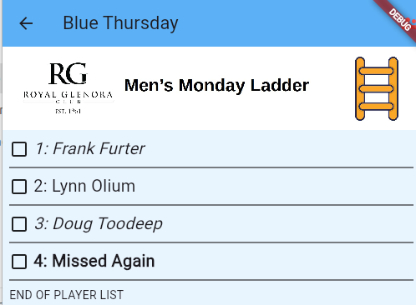

The top title line just gives the name of the ladder.
The second line is the image that was uploaded by your administrator.
Then the players are listed in order of their rank. If you click on your name then an extra line will pop into view.
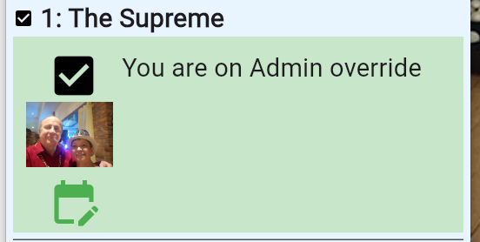
If it is close to the start time for the play of the ladder then you will be give a checkbox that you can click on to indicate that you are Present and ready to play. Note that you should arrive more than 5 minutes ahead of the start time or you may not get to play.
If it does not display an empty box then it might display:
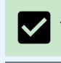
A checked box to say that you have marked your self as present and ready to play

Any other message includes a text description describing why you can not change the Present status.
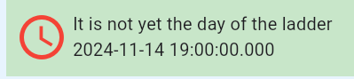

There is also a spot to upload a picture of yourself. This is highly recommended as other players who don’t know you will be able to recognize you.
Also there is an icon of a calendar:


Click on this to view the calendar of scheduled days and time of play as well as giving you a place for you to mark your self as away for any of those scheduled days. This calendar also gives you a way to see scores for previous days.

